**Project Initialization and Planning Phase**

| Date | 12th July 2024 |
| --- | --- |
| Team ID |  |
| Project Name | TripTrek : Intelligent Travel Planning Using Palm’s Chat-Bison-001 |
| Maximum Marks | 3 Marks |

**Define Problem Statements (Customer Problem Statement Template):**

Create a problem statement to understand your customer's point of view. The Customer Problem Statement template helps you focus on what matters to create experiences people will love. A well-articulated customer problem statement allows you and your team to find the ideal solution for your customers' challenges. Throughout the process, you’ll also be able to empathize with your customers, which helps you better understand how they perceive your product or service.

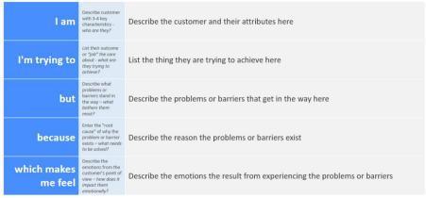

Reference: https://miro.com/templates/customer-problem-statement/

**Example:**

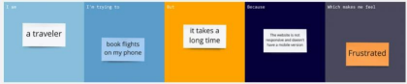

|  |  |  |  |  |  |
| --- | --- | --- | --- | --- | --- |
| **Problem**  **Statement (PS)** | **I am**  **(Customer)** | **I’m trying to** | **But** | **Because** | **Which makes me feel** |
| PS-1 | A traveler | Plan my trip to Italy with budget constraints | I don’t know where to start | I’m unfamiliar with the country and there’s too many sources to look from in order to decide the cheapest and best option. | Stressed, poor, and anxious, irritated. |
| PS-2 | A business professional | Decide accommodations for my business trip to Los Angeles | I’m too busy to look through all the options to decide the best one | I don’t have the time for something like this with my immense workload | Inefficient, hurried, pressured. |
| PS-3 | A Father | Plan my Family trip with just me, my wife and children to Darjeeling | It's very difficult to decide the best destinations and itinerary with the optimal schedule that gives ample amount of rest while ensuring our enjoyment | I don’t know the area and have never booked a flight before | Stressed, anxious, concerned. |